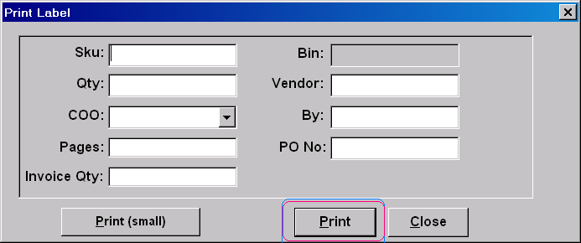

- To remove the print tab, user will be using Print (small) only.
- Label printed of the indication no. of printing not printed in full view – need to adj alignment to the right .Example : correct view should be (1/10000) but right now seen as /10000)
- Coo – cannot view in full
- Vendor : Font size too big

